#Code:
- For input x[n] = [1, 0, 1, 1] and impulse response h[n] = [1, -1, 0, 1]
x = [1, 0, 1, 1];
h = [1, -1, 0, 1];
y = conv(x, h);
subplot(3, 1, 1)
stem(x,'filled', "LineWidth", 2.5)
title('Input signal x[n]')
xlabel('n')
ylabel('x[n]')
grid on
subplot(3, 1, 2)
stem(h, 'filled', "LineWidth", 2.5)
title('Impulse response h[n]')
xlabel('n')
ylabel('h[n]')
grid on
subplot(3, 1, 3)
stem(y, 'filled', "LineWidth", 2.5)
title('Output signal y[n]')
xlabel('n')
ylabel('y[n]')
grid on

- For input x[n] = (0.5)^{n} and impulse response h[n] = [1,1,1,1,1,1,1,1,1,1,1]
n = 0:10;
x = 0.5.^n;
h = ones(1, 11);
y = conv(x, h);
subplot(3, 1, 1)
stem(x,'filled', "LineWidth", 2.5)
title('Input signal x[n]')
xlabel('n')
ylabel('x[n]')
grid on
subplot(3, 1, 2)
stem(h, 'filled', "LineWidth", 2.5)
title('Impulse response h[n]')
xlabel('n')
ylabel('h[n]')
grid on
subplot(3, 1, 3)
stem(y, 'filled', "LineWidth", 2.5)
title('Output signal y[n]')
xlabel('n')
ylabel('y[n]')
grid on

Results:
- For input x[n] = [1, 0, 1, 1] and impulse response h[n] = [1, -1, 0, 1]

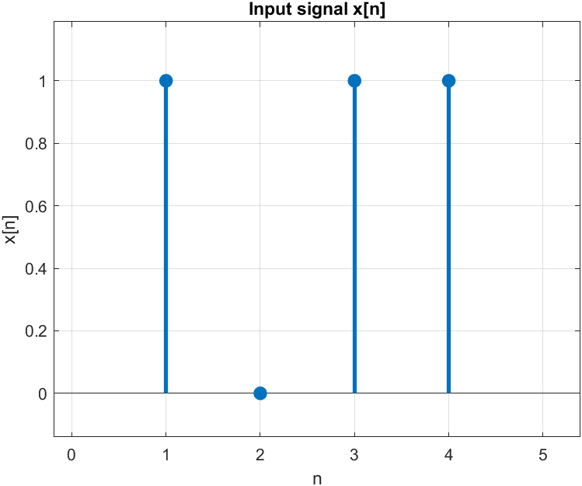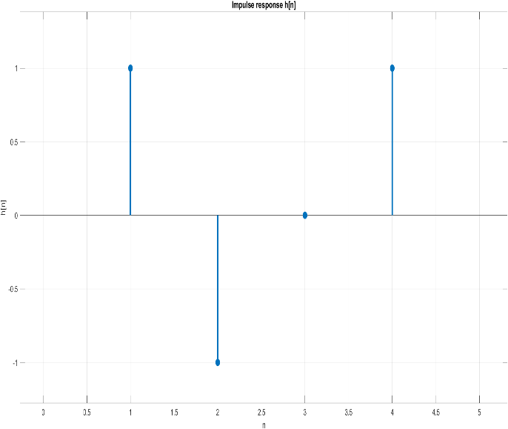
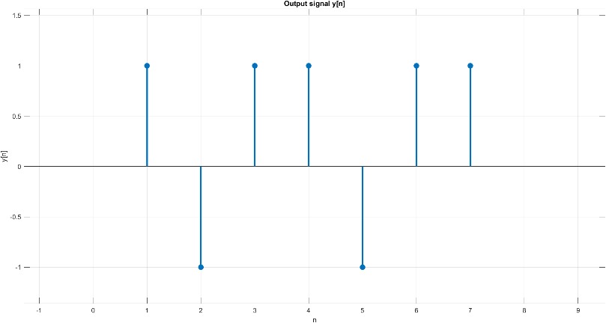

- For input x[n] = (0.5)^{n} and impulse response h[n] = [1,1,1,1,1,1,1,1,1,1,1]


